# CS 255 DriverPass System Design Document

## UML Diagrams

### UML Use Case Diagram

### UML Activity Diagrams

### UML Sequence Diagram

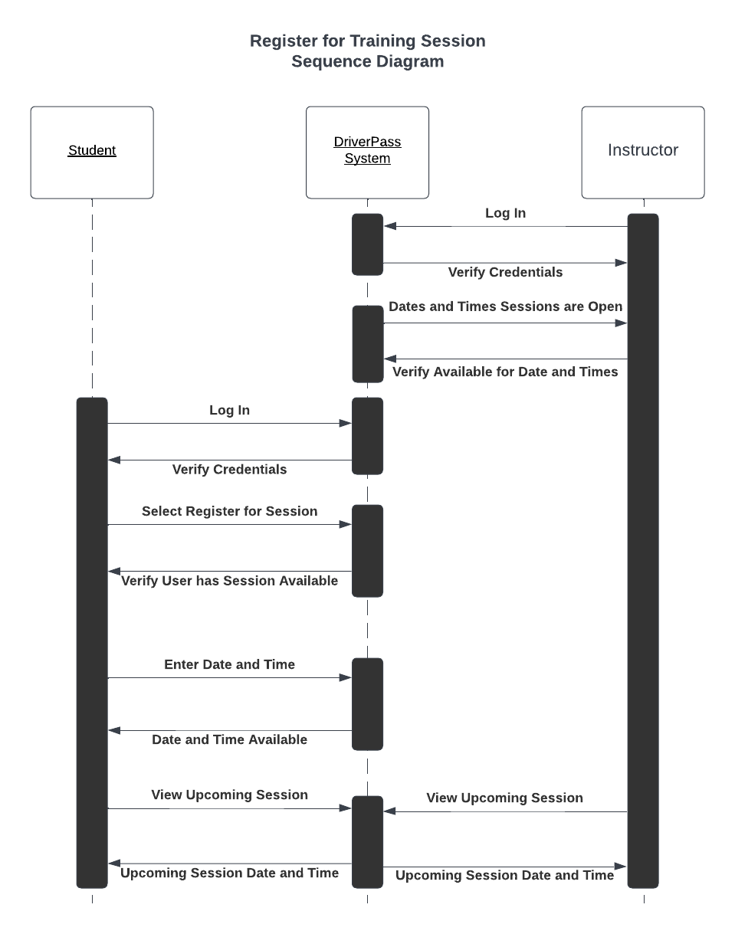

### UML Class Diagram

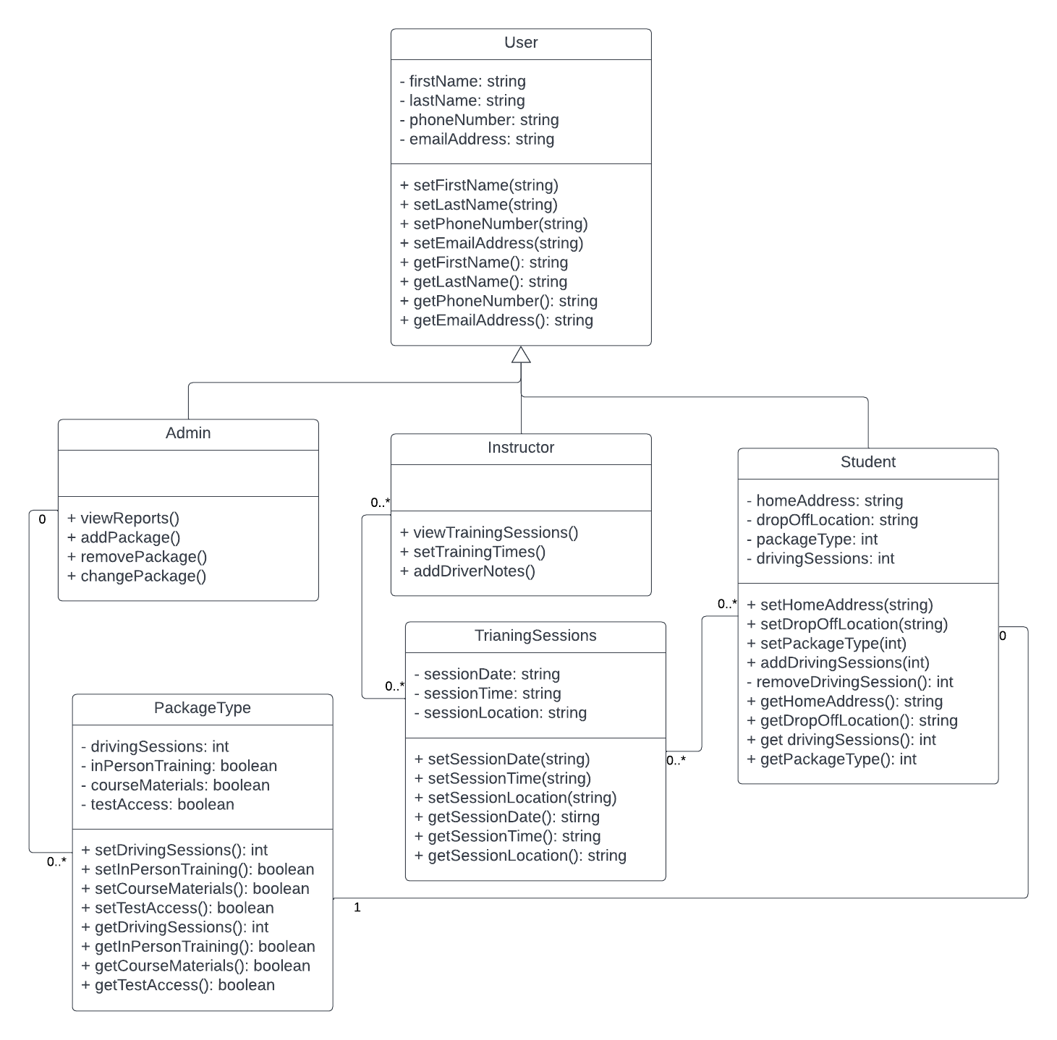

## Technical Requirements

The DriverPass system will use a cloud-based server using a client-server design pattern to add security to the system. Access to the system will be through an internet browser on either a computer or smartphone.